WEEK 1 REPORT
Financial Data Exploration & Python Environment Setup
A first look at used-vehicle pricing and depreciation using Python, Pandas, NumPy and Matplotlib
Prepared by: Swarup Bhosale
Role: Junior Data Analyst (Financial Analytics)
Date: October 2026
Dataset: car_prediction_data.csv (301 records, 9 columns)

1. Introduction
This report documents my first week of work as a Junior Data Analyst. The goal was simple to state and surprisingly rich to carry out: build a reliable Python analytics environment, pick a public dataset with a financial angle, load it, understand it, and draw a few honest conclusions from it.
I have tried to write this the way I would explain it to a colleague joining the project next month. For every step I note what I did, why I did it, and what I learned, including the one moment where the data surprised me and changed my approach (see Section 5).

1.1 Objectives
- Set up a clean Python environment with Anaconda and the core analytics libraries.
- Select a publicly available dataset that involves money, pricing or value.
- Load the data with Pandas and check its quality before trusting it.
- Summarise the key metrics and build at least two visualisations (I built six).
- Record patterns and insights in plain language, with the code behind them.

1.2 Why a used-vehicle dataset counts as financial data
A used vehicle is a depreciating asset. Every row in this dataset records what something cost new (Present_Price), what it sold for second-hand (Selling_Price), and the factors that shape the gap between the two: age, usage, fuel type, ownership history and who is selling it. That makes it a compact, realistic case study in asset valuation, depreciation and price drivers, the same questions analysts ask about equipment, property or inventory on a balance sheet.

2. Python Environment Setup
A good analysis starts with a reproducible environment. I chose Anaconda because it bundles Python, a package manager (conda) and Jupyter Notebook in one installer, and it lets me keep each project in its own isolated environment so library versions never clash.

2.1 Step-by-step setup
- Download Anaconda. Install the Individual Edition for your operating system from anaconda.com and accept the default options.
- Open Anaconda Prompt (Windows) or a terminal (macOS/Linux) and confirm the install with the command below.
conda --version

- Create a dedicated environment. Naming it after the task keeps things tidy. I pinned Python 3.11 for stability.
conda create -n fin-analytics python=3.11 -y
conda activate fin-analytics

- Install the libraries. Everything in one command lets conda resolve compatible versions together.
conda install pandas numpy matplotlib seaborn scipy jupyter -y

- Launch Jupyter Notebook from inside the environment and create a new notebook for the project.
jupyter notebook

- Verify the setup by importing every library and printing its version.
import pandas as pd
import numpy as np
import matplotlib
import seaborn as sns

print('pandas :', pd.__version__)
print('numpy :', np.__version__)
print('matplotlib:', matplotlib.__version__)
print('seaborn :', sns.__version__)

Screenshot placeholder
Paste your own screenshot here of the Anaconda Prompt after the install command and the Jupyter notebook showing the version printout. Those are specific to your machine, so I have left the space for you to add them.

2.2 Libraries and why each one is here
Library | Role in this project
Pandas | Loading the CSV, inspecting structure, cleaning, grouping and summarising.
NumPy | Fast numerical operations and conditional logic (for example, tagging vehicle types).
Matplotlib | The base plotting library; every chart is ultimately drawn with it.
Seaborn | Statistical charts (distributions, box plots, heatmaps) with cleaner defaults.
Jupyter | Interactive notebook where code, output and notes live together.

3. Dataset Selection
I chose the used-vehicle listings file (car_prediction_data.csv), a widely shared public dataset of second-hand vehicle sales. I selected it for three reasons: it is small enough to explore thoroughly by hand, it has a clear monetary target (selling price), and it mixes numeric and categorical variables, which lets me practise both kinds of analysis.

3.1 Data dictionary
Column | Type | Meaning
Car_Name | Text | Model name of the vehicle.
Year | Integer | Year of manufacture.
Selling_Price | Decimal | Price the vehicle sold for second-hand (target variable).
Present_Price | Decimal | Current showroom price of the same model when new.
Kms_Driven | Integer | Total kilometres on the odometer.
Fuel_Type | Category | Petrol, Diesel or CNG.
Seller_Type | Category | Dealer or Individual.
Transmission | Category | Manual or Automatic.
Owner | Integer | Number of previous owners.

Assumption
The file does not state its currency or unit. Based on the value ranges and the common convention for this dataset, I treat both price columns as Indian rupees in lakhs (1 lakh = 100,000). All price charts are labelled accordingly. If the source documentation says otherwise, only the axis labels need to change.

4. Loading and First Look
Before any analysis I want to know three things: how big is the data, what does a row look like, and are the data types what I expect.
import pandas as pd
import numpy as np
import matplotlib.pyplot as plt
import seaborn as sns

df = pd.read_csv('car_prediction_data.csv')
print(df.shape)
df.head()

Output
(301, 9)

Car_Name Year Selling_Price Present_Price Kms_Driven Fuel_Type Seller_Type Transmission Owner
0 ritz 2014 3.35 5.59 27000 Petrol Dealer Manual 0
1 sx4 2013 4.75 9.54 43000 Diesel Dealer Manual 0
2 ciaz 2017 7.25 9.85 6900 Petrol Dealer Manual 0
3 wagon r 2011 2.85 4.15 5200 Petrol Dealer Manual 0
4 swift 2014 4.60 6.87 42450 Diesel Dealer Manual 0

df.info()

Output
<class 'pandas.DataFrame'>
RangeIndex: 301 entries, 0 to 300
Data columns (total 9 columns):
# Column Non-Null Count Dtype
--- ------ -------------- -----
0 Car_Name 301 non-null str
1 Year 301 non-null int64
2 Selling_Price 301 non-null float64
3 Present_Price 301 non-null float64
4 Kms_Driven 301 non-null int64
5 Fuel_Type 301 non-null str
6 Seller_Type 301 non-null str
7 Transmission 301 non-null str
8 Owner 301 non-null int64
dtypes: float64(2), int64(3), str(4)
memory usage: 21.3 KB

The dataset has 301 rows and 9 columns. Data types are sensible: numbers are stored as numbers and the four descriptive columns are text categories. There are no missing values reported at this stage. (On older Pandas versions the text columns show as `object` instead of `str`; it means the same thing.)

5. Data Quality Checks and Preparation

5.1 Missing values and duplicates
print(df.isnull().sum())
print('Duplicate rows:', df.duplicated().sum())

Output
Car_Name 0
Year 0
Selling_Price 0
Present_Price 0
Kms_Driven 0
Fuel_Type 0
Seller_Type 0
Transmission 0
Owner 0

Duplicate rows: 2

No column has missing values, which is rare and convenient. However, 2 rows are exact duplicates (an Ertiga from 2016 and a Fortuner from 2015). Duplicates would quietly overweight those records, so I removed them, leaving 299 records for the rest of the analysis.
df = df.drop_duplicates().reset_index(drop=True)
print(df.shape) # (299, 9)

5.2 A surprise: this is not only a car dataset
While scanning the unique values of Car_Name, I noticed names like *Royal Enfield Classic 350*, *Bajaj Pulsar 150* and *Honda Activa 4G*. These are motorcycles and scooters. Counting them showed that roughly one record in three is a two-wheeler, and they behave very differently from cars: median selling price is about ₹0.5 lakh versus about ₹5.25 lakh for cars.
This matters because it quietly distorts other columns. For example, all 101 two-wheelers are listed by Individual sellers, so the apparent gap between dealers and individuals is mostly a vehicle-type effect, not a seller effect. I therefore created a Vehicle_Type column. I identified cars from the list of car model names that appear in the file; everything else is tagged as a two-wheeler.
car_models = ['ritz','sx4','ciaz','wagon r','swift','vitara brezza','s cross',
'alto 800','ertiga','dzire','alto k10','ignis','800','baleno','omni',
'fortuner','innova','corolla altis','etios cross','etios g','etios liva',
'corolla','etios gd','camry','land cruiser','i20','grand i10','i10',
'eon','xcent','elantra','creta','verna','city','brio','amaze','jazz']

df['Vehicle_Type'] = np.where(
df['Car_Name'].str.strip().str.lower().isin(car_models), 'Car', 'Two-wheeler')

print(df['Vehicle_Type'].value_counts())

Output
Vehicle_Type
Car 198
Two-wheeler 101

5.3 Feature engineering
I added two simple columns that turn raw numbers into financial ideas: Car_Age (the vehicle's age in 2026) and Price_Retained_Pct (what percentage of the new price the vehicle still sells for), which is a direct measure of depreciation.
df['Car_Age'] = 2026 - df['Year']
df['Price_Retained_Pct'] = df['Selling_Price'] / df['Present_Price'] * 100

6. Summary Statistics
df[['Year','Selling_Price','Present_Price','Kms_Driven','Owner']].describe().round(2)

Output (after removing duplicates, n = 299)
Statistic | Year | Selling Price | Present Price | Kms Driven | Owner
Mean | 2013.62 | 4.59 | 7.54 | 36,917 | 0.04
Std. dev. | 2.90 | 4.98 | 8.57 | 39,015 | 0.25
Minimum | 2003 | 0.10 | 0.32 | 500 | 0
25% | 2012 | 0.85 | 1.20 | 15,000 | 0
Median | 2014 | 3.51 | 6.10 | 32,000 | 0
75% | 2016 | 6.00 | 9.84 | 48,884 | 0
Maximum | 2018 | 35.00 | 92.60 | 500,000 | 3

What the numbers say
- Prices are right-skewed. The mean selling price (₹4.59 lakhs) sits well above the median (₹3.51 lakhs), and the skewness is 2.54. A few expensive vehicles pull the average up, so the median is the fairer "typical" price.
- Vehicles are mostly recent. Half were made in 2014 or later, and the oldest is from 2003.
- Ownership is almost always first-hand. About 96% of listings have had no previous owner.
- One value looks wrong. A record shows 500,000 km, far above the 75th percentile of about 49,000 km. It belongs to a scooter (Activa 3g) and is probably a data-entry error or an extreme case, so I excluded it from the mileage chart rather than delete it from the data.
- Depreciation is measurable. On average a vehicle still sells for about 63% of its new price (median 65%).

7. Visual Exploration
Numbers summarise; charts reveal. I built six visualisations, each aimed at one question. For every chart I explain why I made it and what it shows.

7.1 How are selling prices distributed?
fig, ax = plt.subplots(figsize=(8, 4.5))
sns.histplot(df['Selling_Price'], bins=30, kde=True, ax=ax)
ax.axvline(df['Selling_Price'].mean(), ls='--', label='Mean')
ax.axvline(df['Selling_Price'].median(), ls=':', label='Median')
ax.set_xlabel('Selling Price (₹ lakhs)')
ax.legend(); plt.show()

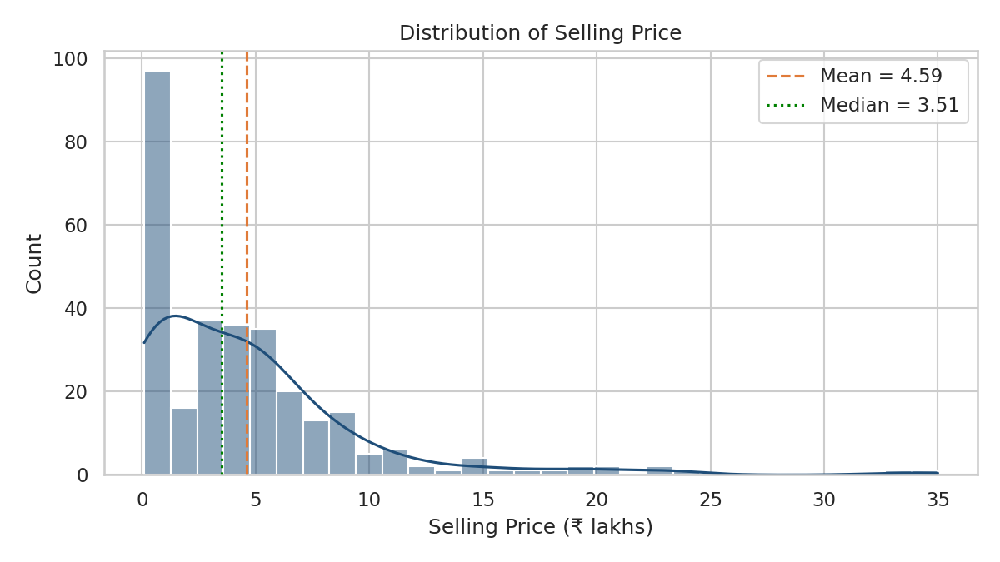
Figure 1: Distribution of selling price (₹ lakhs)
Reading it: the tall block on the left is the large group of low-priced vehicles, mostly two-wheelers and older hatchbacks, with a long tail stretching toward premium SUVs. The mean is dragged to the right of the median, confirming the skew. Any model built on this data should expect price to need a transformation (such as a log) before it behaves nicely.

7.2 How does price change with manufacturing year?
fig, ax = plt.subplots(figsize=(8, 4.5))
for t in ['Car', 'Two-wheeler']:
g = df[df['Vehicle_Type'] == t].groupby('Year')['Selling_Price'].mean()
ax.plot(g.index, g.values, marker='o', label=t)
ax.set_xlabel('Manufacturing Year'); ax.set_ylabel('Avg Selling Price (₹ lakhs)')
ax.legend(); plt.show()

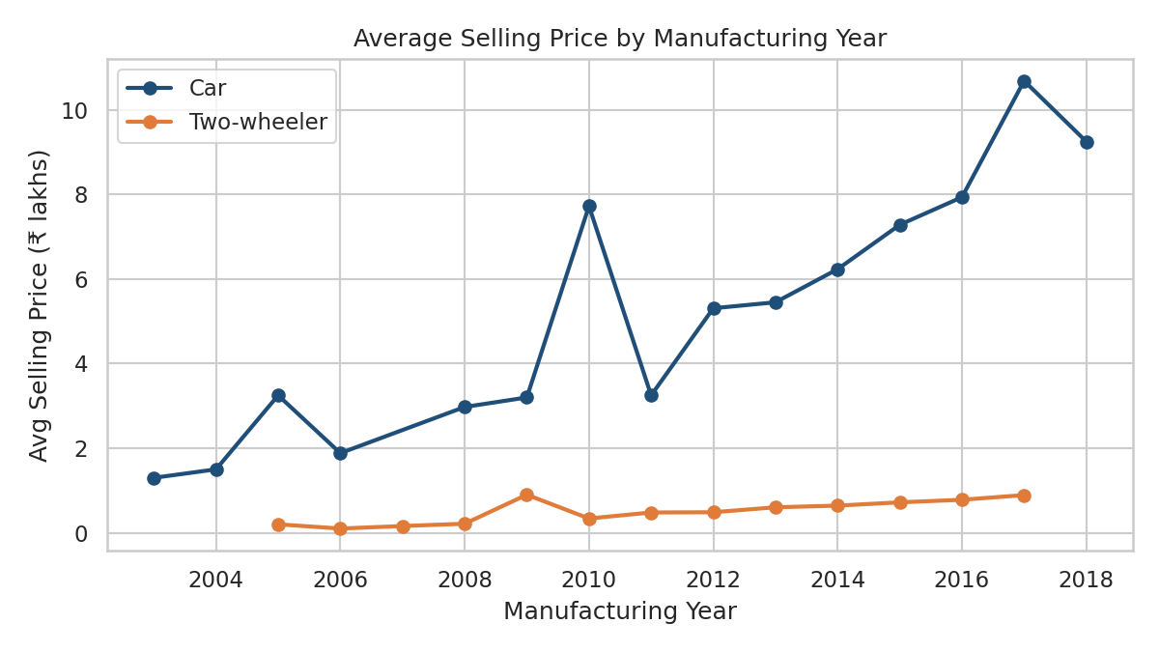
Figure 2: Average selling price by manufacturing year
Reading it: newer cars generally sell for more, but the line is jagged, and the car line is much higher than the two-wheeler line throughout. Years with only a handful of records (2003–2009 and 2018) swing wildly because a single vehicle can move the average. The jaggedness is a reminder that year alone does not set the price; what the vehicle was worth new matters more.

7.3 What was it worth new versus now?
fig, ax = plt.subplots(figsize=(8, 4.5))
sns.scatterplot(data=df, x='Present_Price', y='Selling_Price', hue='Vehicle_Type', alpha=0.75, ax=ax)
ax.set_xlabel('Present Price (₹ lakhs)'); ax.set_ylabel('Selling Price (₹ lakhs)')
plt.show()

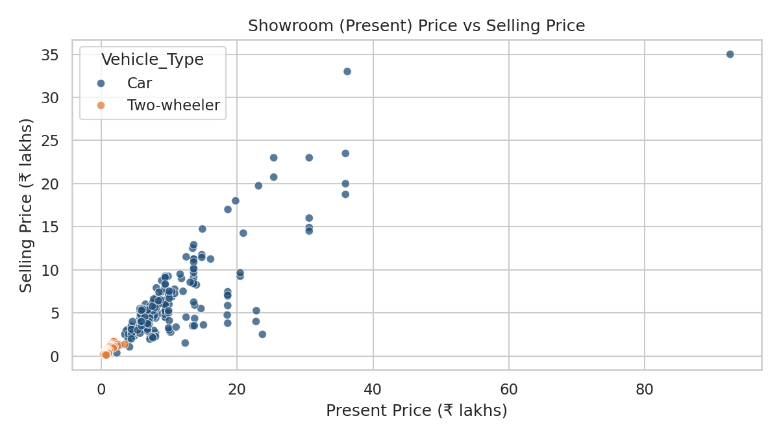
Figure 3: Showroom (present) price versus selling price
Reading it: this is the strongest relationship in the dataset, with a correlation of 0.88. Points hug an upward line: expensive models stay expensive second-hand. The vehicles below that line have lost more value. The most striking point is a 2010 Land Cruiser listed at ₹92.6 lakhs new that sold for ₹35 lakhs, which is both the highest price and the biggest outlier on both axes.

7.4 Does fuel, transmission or vehicle type matter?
fig, axs = plt.subplots(1, 3, figsize=(11, 4.2))
for ax, col in zip(axs, ['Fuel_Type', 'Transmission', 'Vehicle_Type']):
sns.boxplot(data=df, x=col, y='Selling_Price', ax=ax)
plt.tight_layout(); plt.show()

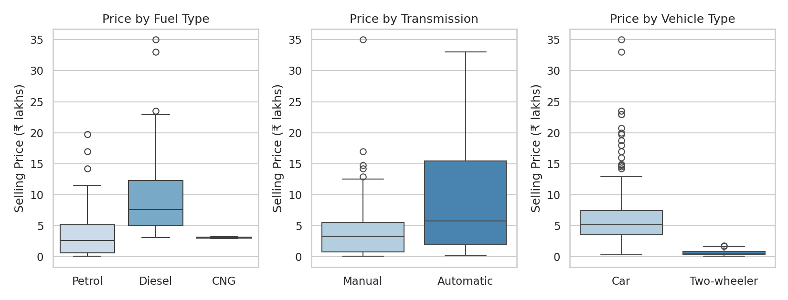
Figure 4: Selling price by fuel type, transmission and vehicle type
Reading it: diesel vehicles sell for noticeably more than petrol (mean ₹10.10 lakhs versus ₹3.26 lakhs), and automatics for more than manuals (₹9.07 versus ₹3.92). Vehicle type is the biggest separator of all. Two cautions: these groups overlap with each other (automatics and diesels tend to be larger, pricier cars), and CNG has only 2 records, so I cannot say anything reliable about it. Among cars only, diesel still leads petrol (₹10.10 versus ₹5.18 lakhs on average), so the fuel effect is real and not just a vehicle-type artefact.

7.5 How do the numeric variables relate?
corr = df[['Year','Selling_Price','Present_Price','Kms_Driven','Owner']].corr()
sns.heatmap(corr, annot=True, fmt='.2f', cmap='coolwarm', center=0)
plt.show()

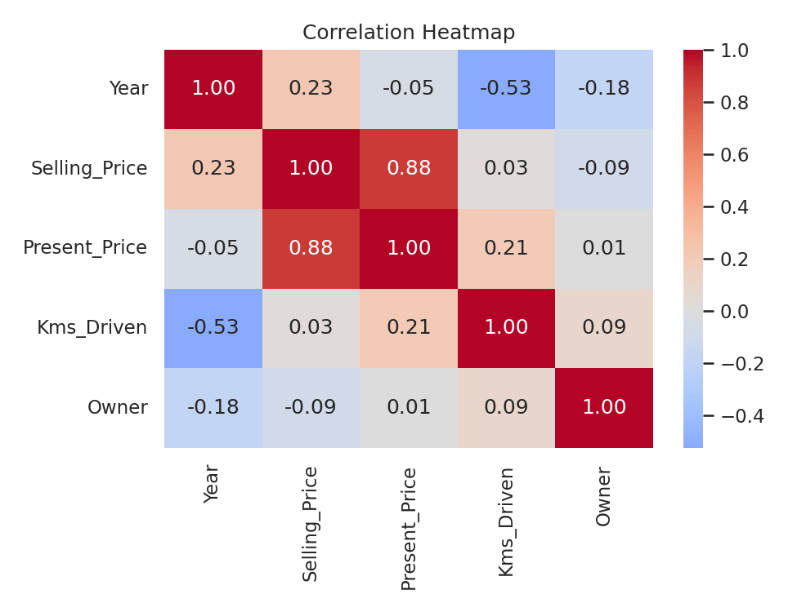
Figure 5: Correlation heatmap of numeric variables
Reading it: Selling price is tied tightly to present price (0.88) and only weakly to year (0.23). Mileage shows almost no direct link to price (0.03), which surprised me. The reason is that mileage is entangled with age (-0.53 with year): older vehicles have more kilometres, and those effects are mixed up with the price differences between models. This is a good example of why a correlation coefficient alone can mislead.

7.6 Kilometres driven versus price
d = df[df['Kms_Driven'] < 200000] # exclude the 500,000 km record
sns.scatterplot(data=d, x='Kms_Driven', y='Selling_Price', hue='Vehicle_Type')
plt.show()

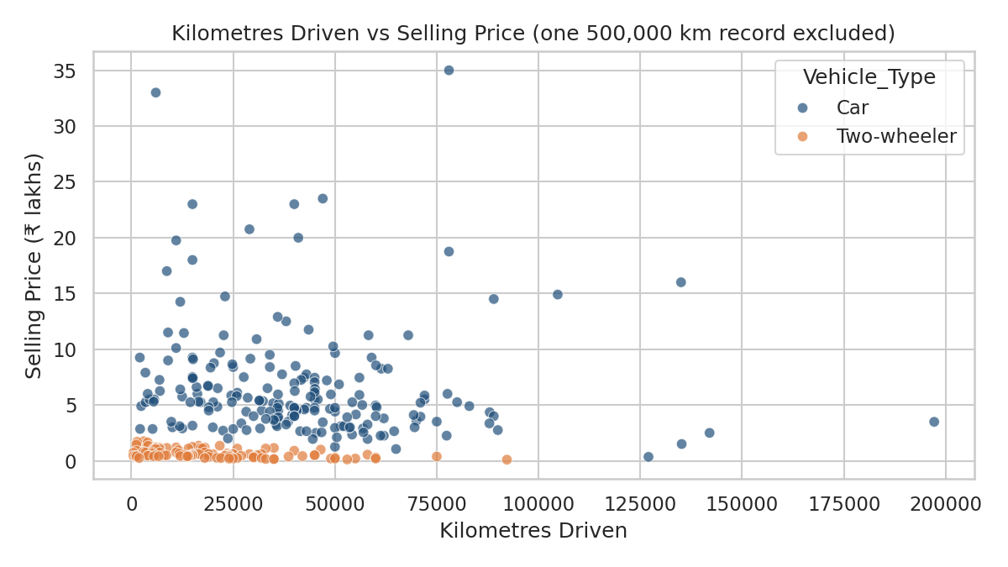
Figure 6: Kilometres driven versus selling price
Reading it: there is no clean downward slope. High-priced cars appear at both low and moderate mileage, while two-wheelers cluster near the bottom regardless of distance. Mileage clearly does not act alone; it has to be combined with model, age and vehicle type to say anything useful about price.

8. Key Insights
- Depreciation is real but uneven. On average vehicles sell for about 63% of their new price. Looking at cars only, those made in 2010 retain roughly 37% of their value, those from 2014 about 63%, and those from 2017 about 87%. Value keeps falling with age and levels off at roughly 20 to 30% of the new price for the oldest vehicles.
- What it cost new is the best single predictor of resale value (correlation 0.88), far stronger than age, mileage or number of owners.
- Diesel and automatic vehicles command a premium, and the diesel premium survives after separating cars from two-wheelers.
- Mileage looks unimportant only because it is tangled up with age. It should not be dismissed.
- The dataset mixes two different markets. Treating cars and two-wheelers as one population would give misleading averages and would make "seller type" look more influential than it is.
- Prices are strongly skewed, so the median is a safer summary than the mean, and a log transformation will be worth testing before any modelling.

Limitations
- The sample is small (299 records), and some years and fuel types have only a few records.
- The file has no date of sale, location or condition information, all of which affect real prices.
- Currency and unit are assumed (rupees in lakhs), and Car_Age uses 2026 as the reference year.
- The car-versus-two-wheeler tag was built from model names and could contain a small number of mistakes.

9. Challenges and What I Learned
- Looking beyond the column headers. The file is named for cars, but reading the actual values revealed motorcycles. Checking unique values early saved me from drawing wrong conclusions.
- Correlation is not the whole story. Mileage looked irrelevant until I saw how it overlaps with age.
- Small groups deserve humility. I resisted reading too much into CNG (2 records) or the early years with a handful of cars.
- Documenting as I went made it far easier to explain each decision, and will make the next task faster.

10. Conclusion and Next Steps
In this first week I built a working Python analytics environment, loaded and cleaned a real dataset, and used it to answer practical questions about depreciation and price drivers. The main takeaway is that resale value is driven mostly by what a vehicle cost new, adjusted by fuel type, transmission and age, and that clean, honest preparation (removing duplicates, noticing the two-wheelers) matters as much as the charts.
Suggested next steps:
- Analyse cars and two-wheelers separately for cleaner comparisons.
- Treat the 500,000 km record and the Land Cruiser as formal outliers and test how much they influence results.
- Try a log transformation on price and fit a simple regression to quantify the effect of each factor.
- Extend the depreciation analysis with a year-by-year value-retention curve.

Appendix: Complete Analysis Script
The full script below reproduces every table and chart in this report. Save it next to the CSV file and run it inside the fin-analytics environment.
import pandas as pd, numpy as np
import matplotlib.pyplot as plt, seaborn as sns

sns.set_theme(style='whitegrid')

# 1. Load and clean
df = pd.read_csv('car_prediction_data.csv')
df = df.drop_duplicates().reset_index(drop=True)

car_models = ['ritz','sx4','ciaz','wagon r','swift','vitara brezza','s cross',
'alto 800','ertiga','dzire','alto k10','ignis','800','baleno','omni',
'fortuner','innova','corolla altis','etios cross','etios g','etios liva',
'corolla','etios gd','camry','land cruiser','i20','grand i10','i10',
'eon','xcent','elantra','creta','verna','city','brio','amaze','jazz']
df['Vehicle_Type'] = np.where(
df['Car_Name'].str.strip().str.lower().isin(car_models), 'Car', 'Two-wheeler')
df['Car_Age'] = 2026 - df['Year']
df['Price_Retained_Pct'] = df['Selling_Price'] / df['Present_Price'] * 100

# 2. Summary
print(df.describe().round(2))
print(df.groupby('Fuel_Type')['Selling_Price'].agg(['count','mean','median']))
print(df.groupby('Transmission')['Selling_Price'].agg(['count','mean','median']))
print(df.groupby('Vehicle_Type')['Selling_Price'].agg(['count','mean','median']))

# 3. Charts
sns.histplot(df['Selling_Price'], bins=30, kde=True); plt.show()

for t in ['Car', 'Two-wheeler']:
g = df[df['Vehicle_Type'] == t].groupby('Year')['Selling_Price'].mean()
plt.plot(g.index, g.values, marker='o', label=t)
plt.legend(); plt.show()

sns.scatterplot(data=df, x='Present_Price', y='Selling_Price', hue='Vehicle_Type'); plt.show()

fig, axs = plt.subplots(1, 3, figsize=(11, 4.2))
for ax, col in zip(axs, ['Fuel_Type', 'Transmission', 'Vehicle_Type']):
sns.boxplot(data=df, x=col, y='Selling_Price', ax=ax)
plt.tight_layout(); plt.show()

sns.heatmap(df[['Year','Selling_Price','Present_Price','Kms_Driven','Owner']].corr(),
annot=True, fmt='.2f', cmap='coolwarm', center=0); plt.show()

d = df[df['Kms_Driven'] < 200000]
sns.scatterplot(data=d, x='Kms_Driven', y='Selling_Price', hue='Vehicle_Type'); plt.show()

